SHIFTWORK SOLUTIONS LLC
Master Schedule Catalog
Every schedule concept for the Work-Life Balance survey — for review & critique

Purpose. This catalog collects every distinct schedule I can find that you have shown, or would likely show, on a shift-schedule concept survey, drawn from your Definitive Schedules v2.xlsx and your concept-survey documents. Grids use your spreadsheet format (D12 / N12 / off). Each schedule has a few key facts and a blank Critique box — rename it, correct the rotation, merge duplicates, delete what you'd never show, or note anything to add, and I'll fold your edits into the survey app.
Please note: names and averages are provisional and computed straight from the grids. Some entries are the day-half and night-half of the same system, or long-cycle variants — kept separate so nothing is hidden. Tell me which to combine.

8-Hour Schedules

Schedule #1 — 8-hour rotating (Day/Eve), 2-week cycle
Shift length: 8-hour · Cycle: 2 week(s) · Avg: 40.0 hrs/week · Source: Definitive Schedules v2.xlsx (Hoffmaster)
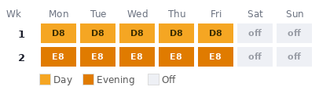
Your critique / changes:

Schedule #2 — 8-hour rotating (Day/Eve/Night), 4-week cycle
Shift length: 8-hour · Cycle: 4 week(s) · Avg: 42.0 hrs/week · Source: Definitive Schedules v2.xlsx (Sheet1)
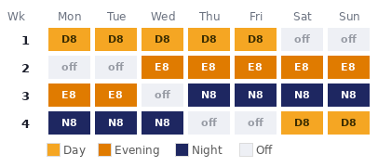
Your critique / changes:

Schedule #3 — 8-hour rotating (Day/Night/Swing), 4-week cycle
Shift length: 8-hour · Cycle: 4 week(s) · Avg: 42.0 hrs/week · Source: Definitive Schedules v2.xlsx (Sheet1)
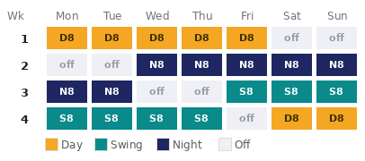
Your critique / changes:

Schedule #4 — 8-hour fixed Day, 4-week cycle
Shift length: 8-hour · Cycle: 4 week(s) · Avg: 42.0 hrs/week · Source: Definitive Schedules v2.xlsx (Sheet1)
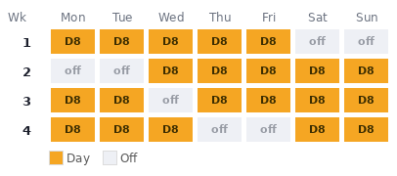
Your critique / changes:

Schedule #5 — 8-hour fixed Evening, 4-week cycle
Shift length: 8-hour · Cycle: 4 week(s) · Avg: 42.0 hrs/week · Source: Definitive Schedules v2.xlsx (Sheet1)
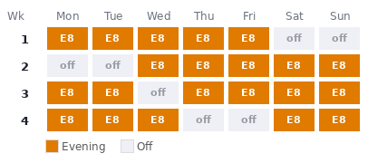
Your critique / changes:

Schedule #6 — 8-hour fixed Night, 4-week cycle
Shift length: 8-hour · Cycle: 4 week(s) · Avg: 42.0 hrs/week · Source: Definitive Schedules v2.xlsx (Sheet1)
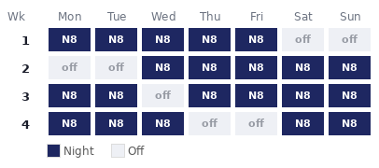
Your critique / changes:

12-Hour Schedules

Schedule #7 — 12-hour 2-2-3, every other weekend off
Shift length: 12-hour · Cycle: 2 week(s) · Avg: 42.0 hrs/week · Source: Definitive Schedules v2.xlsx (Sheet1)
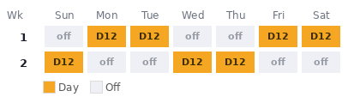
Your critique / changes:

Schedule #8 — 12-hour 2-2-3, every other weekend off
Shift length: 12-hour · Cycle: 2 week(s) · Avg: 42.0 hrs/week · Source: Definitive Schedules v2.xlsx (Sheet1)
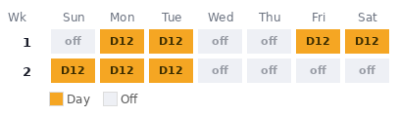
Your critique / changes:

Schedule #9 — 12-hour 2-2-3, every other weekend off
Shift length: 12-hour · Cycle: 2 week(s) · Avg: 42.0 hrs/week · Source: Definitive Schedules v2.xlsx (Sheet1)
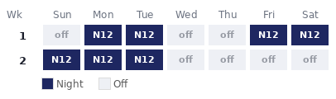
Your critique / changes:

Schedule #10 — 12-hour 2-2-3, every other weekend off
Shift length: 12-hour · Cycle: 2 week(s) · Avg: 42.0 hrs/week · Source: Definitive Schedules v2.xlsx (Sheet1)
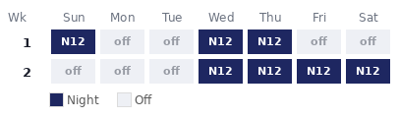
Your critique / changes:

Schedule #11 — 12-hour 2-2-3, every other weekend off
Shift length: 12-hour · Cycle: 2 week(s) · Avg: 42.0 hrs/week · Source: Definitive Schedules v2.xlsx (Hoffmaster)
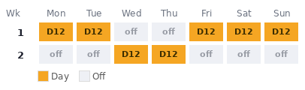
Your critique / changes:

Schedule #12 — 12-hour fixed Day, 3-week cycle
Shift length: 12-hour · Cycle: 3 week(s) · Avg: 48.0 hrs/week · Source: Definitive Schedules v2.xlsx (Hoffmaster)
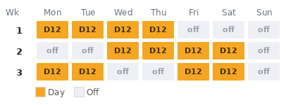
Your critique / changes:

Schedule #13 — 12-hour rotating (Day/Night), 4-week cycle
Shift length: 12-hour · Cycle: 4 week(s) · Avg: 42.0 hrs/week · Source: Definitive Schedules v2.xlsx (Sheet1)
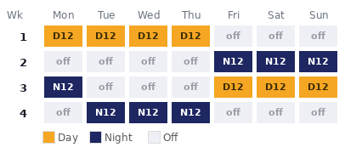
Your critique / changes:

Schedule #14 — 12-hour rotating (Day/Night), 4-week cycle
Shift length: 12-hour · Cycle: 4 week(s) · Avg: 42.0 hrs/week · Source: Definitive Schedules v2.xlsx (Sheet1)
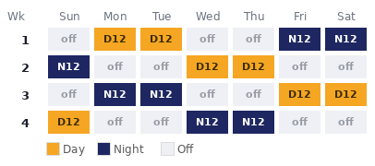
Your critique / changes:

Schedule #15 — 12-hour rotating (Day/Night), 4-week cycle
Shift length: 12-hour · Cycle: 4 week(s) · Avg: 42.0 hrs/week · Source: Definitive Schedules v2.xlsx (Sheet1)
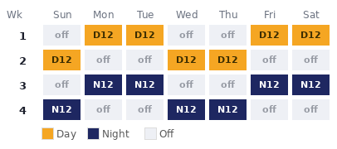
Your critique / changes:

Schedule #16 — 12-hour fixed Day, 4-week cycle
Shift length: 12-hour · Cycle: 4 week(s) · Avg: 42.0 hrs/week · Source: Definitive Schedules v2.xlsx (Sheet1)
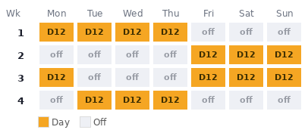
Your critique / changes:

Schedule #17 — 12-hour fixed Night, 4-week cycle
Shift length: 12-hour · Cycle: 4 week(s) · Avg: 42.0 hrs/week · Source: Definitive Schedules v2.xlsx (Sheet1)
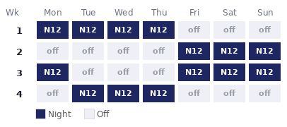
Your critique / changes:

Schedule #18 — 12-hour rotating (Day/Night), 4-week cycle
Shift length: 12-hour · Cycle: 4 week(s) · Avg: 42.0 hrs/week · Source: Definitive Schedules v2.xlsx (Sheet1)
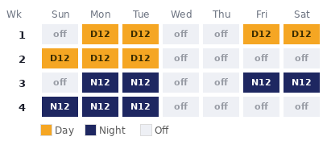
Your critique / changes:

Schedule #19 — 12-hour rotating (Day/Night), 4-week cycle
Shift length: 12-hour · Cycle: 4 week(s) · Avg: 42.0 hrs/week · Source: Definitive Schedules v2.xlsx (Sheet1)
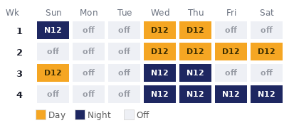
Your critique / changes:

Schedule #20 — 12-hour rotating (Day/Night), 4-week cycle
Shift length: 12-hour · Cycle: 4 week(s) · Avg: 42.0 hrs/week · Source: Definitive Schedules v2.xlsx (Sheet1)
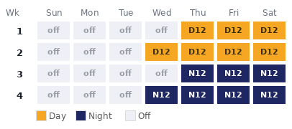
Your critique / changes:

Schedule #21 — 12-hour single-shift, 6-week cycle
Shift length: 12-hour · Cycle: 6 week(s) · Avg: 42.0 hrs/week · Source: Definitive Schedules v2.xlsx (Sheet1)
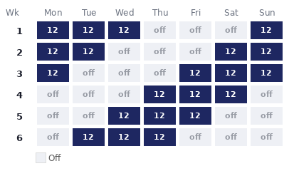
Your critique / changes:

Schedule #22 — 12-hour single-shift, 6-week cycle
Shift length: 12-hour · Cycle: 6 week(s) · Avg: 42.0 hrs/week · Source: Definitive Schedules v2.xlsx (Sheet1)
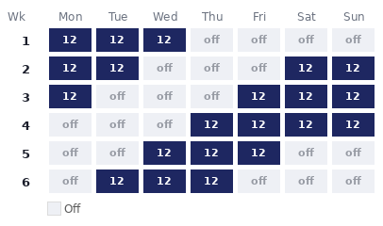
Your critique / changes:

Schedule #23 — 12-hour fixed Day, 6-week cycle
Shift length: 12-hour · Cycle: 6 week(s) · Avg: 42.0 hrs/week · Source: Definitive Schedules v2.xlsx (Sheet1)
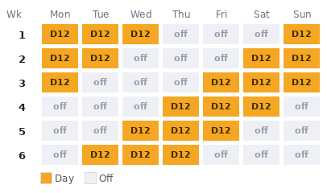
Your critique / changes:

Schedule #24 — 12-hour single-shift, 8-week cycle
Shift length: 12-hour · Cycle: 8 week(s) · Avg: 42.0 hrs/week · Source: Definitive Schedules v2.xlsx (Sheet1)
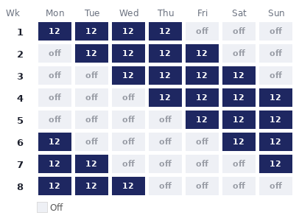
Your critique / changes:

Schedule #25 — 12-hour rotating (Day/Night), 8-week cycle
Shift length: 12-hour · Cycle: 8 week(s) · Avg: 42.0 hrs/week · Source: Definitive Schedules v2.xlsx (Sheet1)
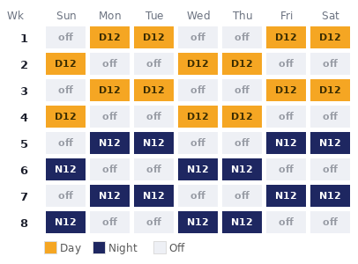
Your critique / changes:

Schedule #26 — 12-hour single-shift, 8-week cycle
Shift length: 12-hour · Cycle: 8 week(s) · Avg: 42.0 hrs/week · Source: Definitive Schedules v2.xlsx (Sheet1)
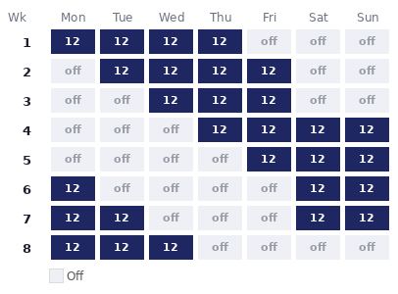
Your critique / changes:

Schedule #27 — 12-hour fixed Day, 8-week cycle
Shift length: 12-hour · Cycle: 8 week(s) · Avg: 42.0 hrs/week · Source: Definitive Schedules v2.xlsx (Sheet1)
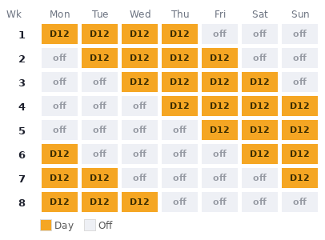
Your critique / changes:

Schedule #28 — 12-hour fixed Night, 8-week cycle
Shift length: 12-hour · Cycle: 8 week(s) · Avg: 42.0 hrs/week · Source: Definitive Schedules v2.xlsx (Sheet1)
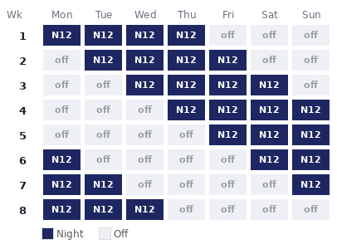
Your critique / changes:

Schedule #29 — 12-hour rotating (Day/Night), 8-week cycle
Shift length: 12-hour · Cycle: 8 week(s) · Avg: 42.0 hrs/week · Source: Definitive Schedules v2.xlsx (Sheet1)
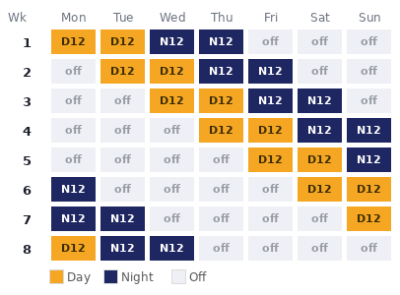
Your critique / changes:

Schedule #30 — 12-hour rotating (Day/Night), 12-week cycle
Shift length: 12-hour · Cycle: 12 week(s) · Avg: 42.0 hrs/week · Source: Definitive Schedules v2.xlsx (Sheet1)
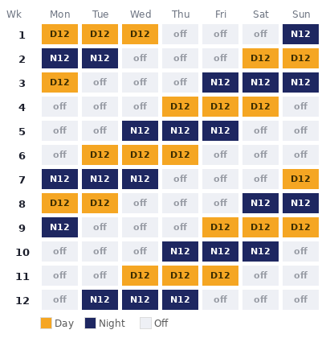
Your critique / changes:

Schedule #31 — 12-hour rotating (Day/Night), 12-week cycle
Shift length: 12-hour · Cycle: 12 week(s) · Avg: 42.0 hrs/week · Source: Definitive Schedules v2.xlsx (Sheet1)
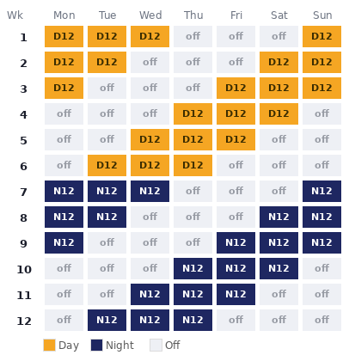
Your critique / changes:

Schedule #32 — 12-hour rotating (Day/Night), 16-week cycle
Shift length: 12-hour · Cycle: 16 week(s) · Avg: 42.0 hrs/week · Source: Definitive Schedules v2.xlsx (Sheet1)
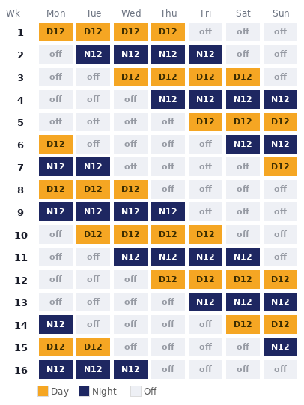
Your critique / changes:

Schedule #33 — 12-hour rotating (Day/Night), 16-week cycle
Shift length: 12-hour · Cycle: 16 week(s) · Avg: 42.0 hrs/week · Source: Definitive Schedules v2.xlsx (Sheet1)
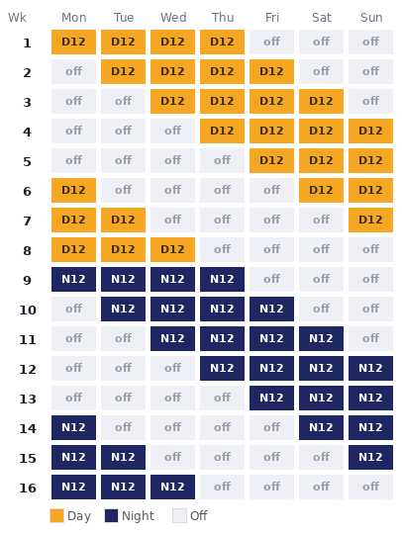
Your critique / changes:

Mixed / Other Shift Lengths

Schedule #34 — 11/12-hour 2-2-3, every other weekend off
Shift length: 11/12-hour · Cycle: 2 week(s) · Avg: 41.5 hrs/week · Source: Definitive Schedules v2.xlsx (Sheet1)
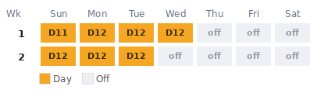
Your critique / changes:

Schedule #35 — 11/12-hour 2-2-3, every other weekend off
Shift length: 11/12-hour · Cycle: 2 week(s) · Avg: 41.5 hrs/week · Source: Definitive Schedules v2.xlsx (Sheet1)
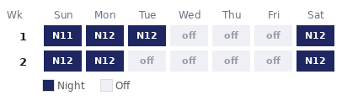
Your critique / changes:

Schedule #36 — 11/12-hour rotating (Day/Night), 4-week cycle
Shift length: 11/12-hour · Cycle: 4 week(s) · Avg: 41.5 hrs/week · Source: Definitive Schedules v2.xlsx (Sheet1)
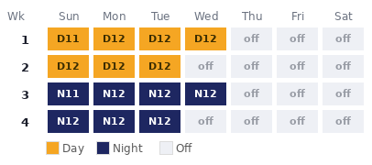
Your critique / changes:

Simple & Overtime Concepts

Schedule #37 — 8-hour — Mon–Fri, every weekend off
Shift length: 8-hour · Cycle: 1 week(s) · Avg: 40 hrs/week · Source: Concept survey (Mondelez)
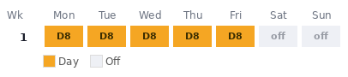
Your critique / changes:

Schedule #38 — 8-hour — Mon–Fri + Saturday overtime
Shift length: 8-hour · Cycle: 1 week(s) · Avg: 48 hrs/week · Source: Concept survey (Mondelez)
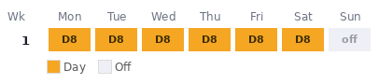
Your critique / changes:

Schedule #39 — 8-hour — Mon–Fri + Saturday & Sunday overtime
Shift length: 8-hour · Cycle: 1 week(s) · Avg: 56 hrs/week · Source: Concept survey (Mondelez)
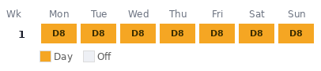
Your critique / changes:

Schedule #40 — Weekend crews — 12-hour day & night
Shift length: 12-hour · Cycle: 2 week(s) · Avg: 36 hrs/week · Source: Concept survey (Mondelez) — weekend crews
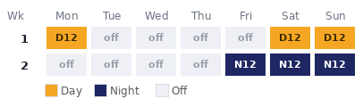
Your critique / changes:

